Lab 05 Rules of Inference
Objective
Solving exercises from the textbook in chapter 1.6 and 1.7(partial)
Current Lab Learning Outcomes (LLO)
By completion of the lab, the students should be able to:
1. use rules of inference to build the arguments.
2. determine the validity of the arguments using rules of inference
3. They will be able to solve shorter/easier or longer / harder problems given in the textbook.

Lab Requirements
Students allowed using their lecture notes in the lab in order to solve the exercises.
Lab Assessment
1- Divide students to groups and let them to solve the given example.
2- Discuss the answers with the groups and write on board the optimal solution

- Use rules of inference to show that the hypotheses “If it does not rain or if it is not foggy, then the sailing race will be held and the lifesaving demonstration will go on,” “If the sailing race is held, then the trophy will be awarded,” and “The trophy was not awarded” imply the conclusion “It rained

Let r be the proposition “it rains,”
Let f be the proposition “It is foggy,”
Let s be the proposition “The sailing race will be held,”
Let l be the proposition “The life saving demonstration will go on,” and
Let t be the proposition “The trophy will be awarded.”
We are given premises (¬r∨ ¬f) →(s∧l), s→t, and ¬t. We want to conclude r.
Note that it is valid to replace sub-expressions by other expressions logically equivalent to them.

Step Reason
1. ¬t Hypothesis
2. s→t Hypothesis
3. ¬s Modus tollens using Steps 1 and 2
4. (¬r∨ ¬f) →(s∧l) Hypothesis
5. (¬ (s∧l)) → ¬(¬r∨ ¬f) Contrapositive of Step 4
6. (¬s∨ ¬l) → (r∧f) De Morgan’s law and double negative
7. (¬s ∨ ¬ l) Addition, using Step 3
8. (r∧f) Modus ponens using Steps 6 and 7
9. r Simplification using Step 8

- Use rules of inference to show that if ∀x(P(x) →(Q(x) ∧ S(x))) and ∀x(P(x) ∧ R(x)) are true, then ∀x(R(x) ∧ S(x)) is true.
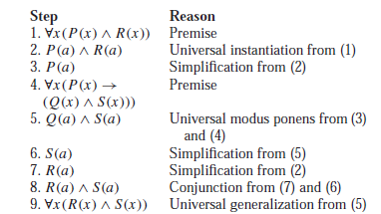

- Use rules of inference to show that if ∀x(P(x) ∨ Q(x)), ∀x(￢Q(x) ∨ S(x)), ∀x(R(x)→￢S(x)), and ∃x￢P(x) are true, then ∃x￢R(x) is true.
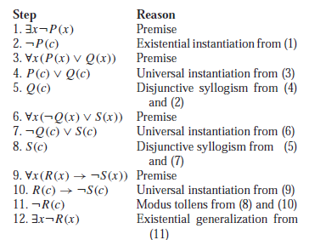

- For each of these arguments, explain which rules of inference are used for each step.
a) “Doug, a student in this class, knows how to write programs in JAVA. Everyone who knows how to write programs in JAVA can get a high-paying job. Therefore, someone in this class can get a high-paying job.”
b) “Somebody in this class enjoys whale watching. Every person who enjoys whale watching cares about ocean pollution. Therefore, there is a person in this class who cares about ocean pollution.”
c) “Each of the 93 students in this class owns a personal computer. Everyone who owns a personal computer can use a word processing program. Therefore, Zeke, a student in this class, can use a word processing program.”
d) “Everyone in New Jersey lives within 50 miles of the ocean. Someone in New Jersey has never seen the ocean. Therefore, someone who lives within 50 miles of the ocean has never seen the ocean.”
Solution: a) Let c(x) be “x is in this class,” j (x) be “x knows how to write programs in JAVA,” and h(x) be “x can get a high-paying job.” The premises are c(Doug), j(Doug), ∀x(j (x) → h(x)). Using universal instantiation and the last premise, j (Doug)→h(Doug) follows. Applying modus ponens to this conclusion and the second premise, h(Doug) follows. Using conjunction and the first premise, c(Doug) ∧ h(Doug) follows. Finally, using existential generalization, the desired conclusion, ∃x(c(x) ∧ h(x)) follows.

or

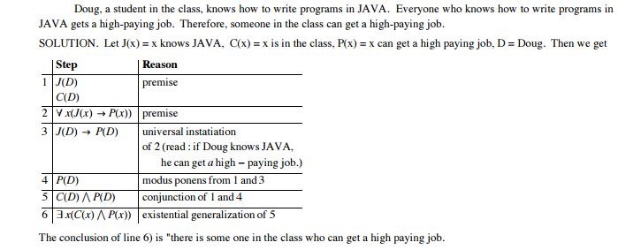
- Let c(x) be “x is in this class,” w(x) be “x enjoys whale watching,” and p(x) be “x cares about ocean pollution.” The premises are ∃x(c(x) ∧ w(x)) and ∀x(w(x) → p(x)). From the first premise, c(y) ∧ w(y) for a particular person y. Using simplification, w(y) follows. Using the second premise and universal instantiation, w(y) → p(y) follows. Using modus ponens, p(y) follows, and by conjunction, c(y) ∧ p(y) follows. Finally, by existential generalization, the desired conclusion, ∃x(c(x) ∧ p(x)), follows.

or

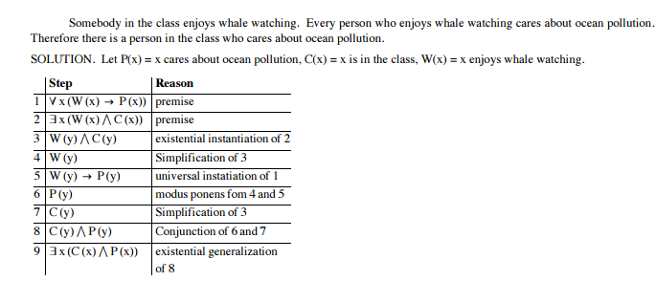
- Let c(x) be “x is in this class,” p(x) be “x owns a PC,” and w(x) be “x can use a word-processing program.” The premises are c(Zeke), ∀x(c(x) → p(x)), and ∀x(p(x) → w(x)). Using the second premise and universal instantiation, c(Zeke) → p(Zeke) follows. Using the first premise and modus ponens, p(Zeke) follows. Using the third premise and universal instantiation, p(Zeke) → w(Zeke) follows. Finally, using modus ponens, w(Zeke), the desired conclusion, follows.

OR

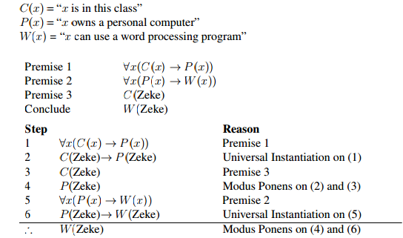
d) Let j (x) be “x is in New Jersey,” f (x) be “x lives within 50 miles of the ocean,” and s(x) be “x has seen the ocean.” The premises are ∀x(j (x) → f (x)) and ∃x(j (x) ∧ ￢s(x)). The second hypothesis and existential instantiation imply that j (y) ∧ ￢s(y) for a particular person y. By simplification, j (y) for this person y. Using universal instantiation and the first premise, j (y) → f (y), and by modus ponens, f (y) follows. By simplification, ￢s(y) follows from j (y)∧￢s(y). So f (y)∧￢s(y) follows by conjunction. Finally, the desired conclusion, ∃x(f (x) ∧ ￢s(x)), follows by existential generalization.

J(x) = “x lives in New Jersey”
O(x) = “x lives within 50 miles of the ocean”
S(x) = “x has seen the ocean”

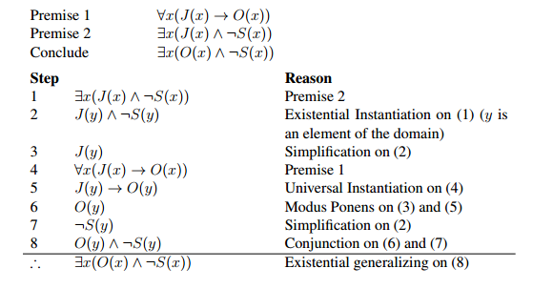

- Show that the premises “If you send me an e-mail message, then I will finish writing the program,” “If you do not send me an e-mail message, then I will go to sleep early,” and “If I go to sleep early, then I will wake up feeling refreshed” lead to the conclusion “If I do not finish writing the program, then I will wake up feeling refreshed.”

Solution: Let p be the proposition “You send me an e-mail message,” q the proposition “I will finish writing the program,” r the proposition “I will go to sleep early,” and s the proposition “I will wake up feeling refreshed.” Then the premises are p → q,￢p → r, and r → s. The desired conclusion is ￢q → s.We need to give a valid argument with premises p → q, ￢p → r, and r → s and conclusion ￢q → s. This argument form shows that the premises lead to the desired conclusion.
Step Reason
1. p → q Premise
2. ￢q →￢p Contrapositive of (1)
3. ￢p → r Premise
4. ￢q → r Hypothetical syllogism using (2) and (3)
5. r → s Premise
6. ￢q → s Hypothetical syllogism using (4) and (5)

- Use a formal proof to prove that the following premises:
(r∧¬s)∨(q∧¬s)
¬s→((p∧r)→u)
u→(s∧¬t)
lead to the conclusion: p→q
Steps Reason
- (r∧¬s)∨(q∧¬s) Premise#1
- ¬s∧( r∨q) Distributive Law on 1
- ¬s Simplification on 2
- ¬s→((p∧r)→u) Premise#2
- ((p∧r)→u) Modus Ponens on 3 and 4
- u→(s∧¬t) Premise #3
- ((p∧r)→(s∧¬t) Hypothetical Syllogism on 5 and 6
- ¬s∨t Addition on 3
- ¬(s∧¬t) DeMorgan's Law on 8
- ¬(p∧r) Modus Tollens on 7 and 9
- ¬p∨¬r DeMorgan's Law on 10
- r∨q Simplification on 2
- ¬p∨q Hypothetical Syllogism on 11 and 12
- p → q Implication Rule on 13
- Use a direct proof to show that the sum of two even integers is even
Solution:Let a=2k,b=2y,
a+b=2a+2y
=2(a+b) =2(m), which is even by the definition of even number, where m=a+b.
- Use a direct proof to show that every odd integer is the difference of two squares.
Solution: Because n is odd, we can write n = 2k + 1 for some integer k. Then
(k+1)²−k² = k²+2k+1−k² = 2k+1 = n.
- Use a direct proof to show that the product of two rational numbers is rational
Solution: Suppose that m,nare rational numbers, i.e. m=a/b, b≠0 and n=c/d, d≠0.
Therfore
m*n = a/b *c/d
= ac/bd where bd≠0.
Then m*n is rational.
- Use a proof by contraposition to show that if x + y ≥2, where x,yare real numbers, then x ≥1 or y ≥ 1.
Solution: Assume that it is not true that x ≥ 1 or y ≥ 1. Then x <1 and y <1. Adding these two inequalities, we obtain x +y <2, which is the negation of x+y≥ 2.

